Mind matters for education and

falling stars theatre

Self-care for working from home and developing confidence for online working.

Mind Matters for Education is a company who focus on delivering Drama workshops that focus on Mental Health. Falling Stars Theatre are a professional theatre company who produce immersive theatre with the audience at the heart of the performance. During these times Beccy has adapted to working online to both create theatre and to deliver drama workshops.
We have collaborated and produced a video presentation that explores ways that you can look after yourself while working from home and looks at developing skills for personal confidence with online presenting and meetings.
We hope that you enjoy our video, and it helps you in some way during these vastly different times.
You are going to meet the characters of ‘Suzie and Sally’, through whom we will explore some of the problems you may be experiencing working from home.
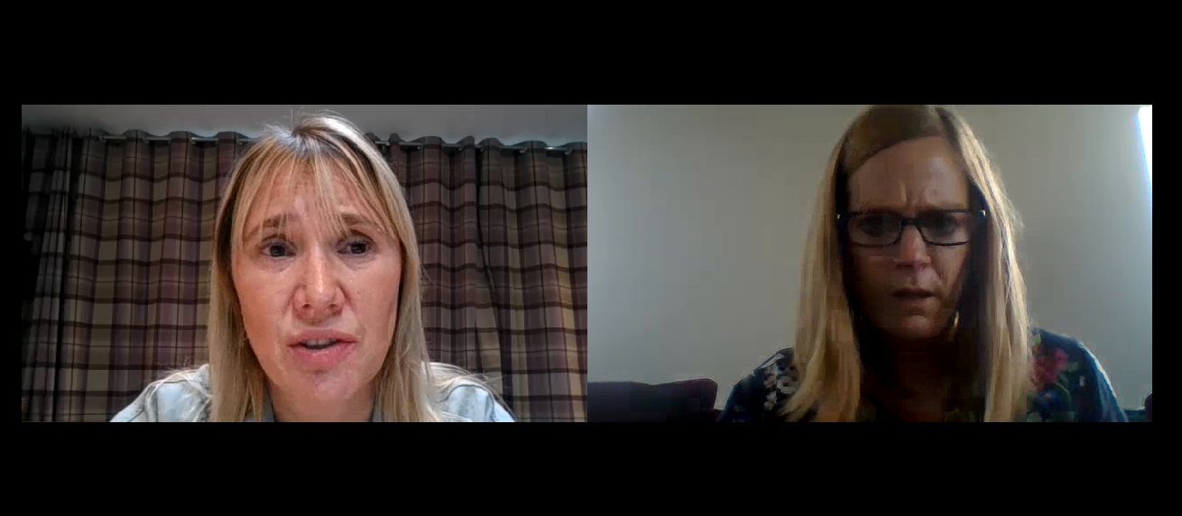

One Minute Stress Focus activity

We would like you to give yourself one timed minute to write down all the personal stresses that you are experiencing now. They may be big or small.
The purpose of this activity is to get out all the things in your mind that may build up and contribute to you finding things difficult working from home.

One Minute Solution Focus activity

We would like you to give yourself one timed minute to write down all the solutions to the personal stresses that you previously wrote down.
Solution based thinking is a positive way to work through difficulties and find ways to mange these.
What can I do to make this situation easier? What can I do to overcome this difficulty?

This format of having 1 minute to write things down, helps to empty your mind of thoughts that may be overwhelming. By writing them down you can then focus on what matters and what you need to do. This activity could be done with the focus being on jobs for the day then the solutions could be to work out a priority list.

solution stratergies for your stresses

Hopefully, you have discovered some strategies for yourself from the solution activity. We have created a top tip list below to address some of the things you may experience when working from home.
- Create a routine. This will help you to keep focused on what you are doing when and allow you to plan in some self-care activities.
- Plan your environment. Working from home presents lots of challenges with lots of possible distractions. Where possible try to define a workspace where there can be limited distractions and interruptions and you feel comfortable in.
- Take a break. Working from home can sometimes lead to over working, use your routine to plan in breaks, whether this is for a walk, a stretch, a drink, a phone call, be sure to do something that gives your mind and eyes a break.
- Connect with people. Whether this is a work colleague, a friend, family, or a stranger out on a walk, it is important to talk to someone to help with feeling isolated.
- Accept things you cannot control. It is important to let go of things that you cannot control. Things may be frustrating, but you can try to find solutions and seek help or support, but sometimes things cannot be controlled.
- Set yourself small tasks. It is normal to procrastinate and find it hard to concentrate at times. By setting small tasks you will reinforce your ability to stay on track.
- Curate your media feed. It may be tempting to visit social media platforms; this can be distracting and have a negative impact. Try to avoid as much as possible, perhaps have set times during breaks to look at social media.
- Focus on the positive. Reflect on the things that you have achieved, no matter how small.
- Focus on the now. Sometimes it is easy and perfectly normal to worry about the future. However, some things are out of our personal control and it is good to try to focus on what we can do in the here and now.
- Avoid unhealthy habits. Turning to things such as alcohol, smoking and caffeine as a way of coping with things will not solve problems, it will just create new ones.
- Be aware that change happens and that you have the skills to adapt.
- Be kind to yourself and others.

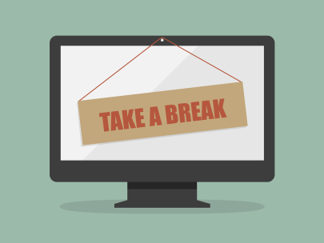

Confidence for Online working

power poses

Presentation Vocal Techniques

Vocal Warm Up
Vowels with different letters in front of them: AEIO

Physical facial warm up movements
- Chewing gum
- Stretch up and out
- Face as small and big as possible

Diction Tongue Twisters
- Leave the lazy lion alone
- Des does a deadly dastardly deed’
- Sister Susie’s sewing shirts for soldiers.

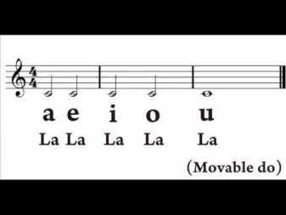
Vocal Techniques

Use of Pace and Pause

Levels of Confidence

Level 1: You as yourself
Level 2: An enhanced version of yourself, for example meeting new people
Level 3: Performance version; confident you
Levels of confidence is about finding the right level for the audience you are presenting too.

